MEDICAL HISTORY II Date: 09/13/21 Time: 10:30

IDENTIFICATION: V.S.
Sex: F Race: Indian Nationality: US Age: 8 Marital status: Single
Address: N/A Religion: N/A
PCD: Dr.Schenker
Informant: Self + Mother Reliability: reliable Referral: PCD

CHIEF COMPLAINT: Cough, headache, emesis x 1 day

8 y/o female came in with her mother with a c/o sore throat, 5/10 headache, cough and emesis since yesterday. Patient reports it started with the sore throat yesterday morning and then progressed to dry cough, headache and emesis once yesterday and once today. She reports the emesis to occur right after the long bouts of cough and consisting of the food she had prior. She states the headache is diffuse, comes and goes, and is exacerbated by the cough. Patient’s mother has similar symptoms which started 3 days ago. Mother gave patient Tylenol which helped with headache only last dose being today at 7am (3 hours ago). Patient denies any fever/chills, SOB, history of reactive airway disease, albuterol use or seasonal allergies. Denies any nausea/vomiting/diarrhea, denies photophobia or dizziness. Mother states patient’s vaccinations are up to date except the Flu vaccine.

PMH: none known
FH: mother with seasonal allergies
PSH: denies any
Allergies: none known
Social History
V.S. lives with her parents at the apartment. She goes to school and reports having a few close friends and doing well in school. Patient reports she has no dietary restrictions and having a healthy appetite except since yesterday when her symptoms began. Denies any exposure to chemicals or smoke at home or in school. Patient’s mother states they have recently moved to a new apartment (3 days ago).

Review of Systems
General: Endorses fatigue. Denies any fever, chills, night sweats, weakness, loss of appetite, recent weight gain or loss

- Skin, hair, nails: Denies any changes in skin texture, excessive dryness or sweating, discolorations, pigmentations, moles/rashes, pruritus or hair loss/changes in distribution
- Head: Endorses 5/10 headache; denies any vertigo, head trauma, unconsciousness, coma, fracture
- Eyes: Denies use of contacts, glasses, visual disturbances, fatigue, lacrimation, photophobia, pruritus
- Ears: Denies any deafness, pain, discharge, tinnitus, hearing aids
- Nose/Sinuses: Endorses congestion and discharge; Denies any epistaxis, obstruction
- Mouth and throat: Denies bleeding gums, sore tongue, sore throat, mouth ulcers, voice changes
- Neck: Denies any localized swelling/lumps, stiffness/decreased range of motion
- Pulmonary system: Endorses cough as per HPI; Denies any dyspnea, wheezing, hemoptysis, cyanosis, orthopnea, PND
- Cardiovascular system: Denies any chest pain, HTN, palpitations, irregular heartbeat, edema/swelling of ankles or feet, syncope, known heart murmur
- Gastrointestinal system: Denies any changes in appetite, intolerance to foods, nausea and vomiting, dysphagia, pyrosis, flatulence, eructation, abdominal pain, diarrhea, jaundice, change in bowel habits, hemorrhoids, constipation, rectal bleeding, blood in stool, pain in flank
- Genitourinary: Denies any frequency, changes in color of urine, incontinence, dysuria, nocturia, urgency, oliguria, polyuria
- Musculoskeletal system: Denies any muscle/joint pain, deformity or swelling, redness
- Peripheral Vascular system: Denies any intermittent claudication, coldness of trophic changes, color change
- Hematologic System: Denies history of anemia, easy bruising or bleeding, lymph node enlargement, history of DVT/PE
- Endocrine system: Denies any polyuria, polydipsia, polyphagia, heat or cold intolerance, goiter, hirsutism
- Nervous system: Denies any seizures, loss consciousness, sensory disturbances (numbness, paresthesia, dysesthesias, hyperesthesia), ataxia, loss of strength, change in cognition/mental status/memory, weakness (asymmetric)
- Psychiatric: Denies any depression/sadness(Feelings of helpless, feelings of hopelessness, lack of interest in usual activities, suicidal ideation), anxiety, obsessive/compulsive disorder

Physical Exam
Vital signs:
- BP: 119/89 RA, sitting upright
- Pulse: 101 BPM
- O2SAT: 97% RA
- Respirations: 20, unlabored
- T: 99.3
- H: 150cm W: 45kg BMI: 20.0
General: Patient is alert & oriented x 3. Well groomed, well dressed, in no distress.
- Skin: Pale. Warm & moist, good turgor. Nonicteric, no scars or tattoos. Cap refill<3 sec throughout.
- Head: non-tender to palpation throughout; no ecchymoses no edema
- Eyes: PERRL; symmetrical OU; no evidence of strabismus, exophthalmos, or ptosis; sclera white, conjunctiva and cornea clear.
- Ears: Symmetrical and normal size. No lesions/masses / trauma on external ears. No discharge / foreign bodies in external auditory canals AU.
- Nose and sinuses: Congestion noted. Frontal, ethmoid and maxillary sinuses are non-tender to palpation. Symmetrical / no masses / lesions / deformities / trauma / discharge. Septum midline
- Throat: Mild erythema in throat noted. No exudates, no petechiae, uvula midline. Mucosa moist. No gross deformities noted in mouth, dentition, and oropharynx.
- Neck: Trachea midline. No masses; lesions; scars; pulsations noted. Supple; non-tender to palpation. FROM; no stridor noted. 2+ Carotid pulses, no thrills; no bruits noted bilaterally, no palpable adenopathy noted.
- Thyroid: Non-tender; no palpable masses; no thyromegaly; no bruits noted.
- Chest: Symmetrical, no deformities, no evidence of trauma. No paradoxic respirations or use of accessory muscles noted. Lat to AP diameter 2:1. Non-tender to palpation.
- Lungs: Diminished breath sounds bilaterally. Chest expansion symmetrical. Clear to auscultation bilaterally. No adventitious sounds. No signs of respiratory distress.
- Heart: Tachycardia noted. Regular rate and rhythm; S1 and S1 with no murmurs or gallops. No splitting of S2 or friction rubs appreciated.
- Abdomen: Soft, flat, and symmetric with no pulsations noted. Bowel sounds normoactive in all four quadrants with no aortic/renal/iliac or femoral bruits. No hepatosplenomegaly to palpation
- Peripheral Vascular: The extremities are normal in color, size and temperature. Pulses are 2+ bilaterally in upper and lower extremities. No bruits noted. No clubbing, No stasis changes or ulcerations noted. No edema.
- MSK: No soft tissue swelling / erythema / ecchymosis / atrophy / or deformities in bilateral upper and lower extremities. Non-tender to palpation / no crepitus noted throughout. No evidence of spinal deformities.
- Neuro: Alert & oriented. No nystagmus. Normal gait.
- Psych: Normal mood, behavior and affect.

DDX:
- Viral URI (influensa, RSV, parainfluenza, etc) – most likely due to presentation, season and pt not being vaccinated for flu
- Cough variant asthma – likely (pt’s mother has seasonal allergies, change of the environment – new apartment, possibly triggered by viral URI)
- Pneumonia – not likely (pt afebrile, no secretions, non-ill appearing)
- Sinusitis – not likely due to no discharge, sinuses are non-tender to palpation
- Allergic rhinitis – diagnosis of exclusion

Assesment/Plan
8 y/o female with likely viral illness, along with diminished air entry in both lungs. I spoke with mom and reviewed my physical exam and discussed the current management plan including trial of albuterol in ED. Will collect and send the viral Genmark panel. Oral challenge while in ED. Mom verbalized understanding and agreement.

Lab results
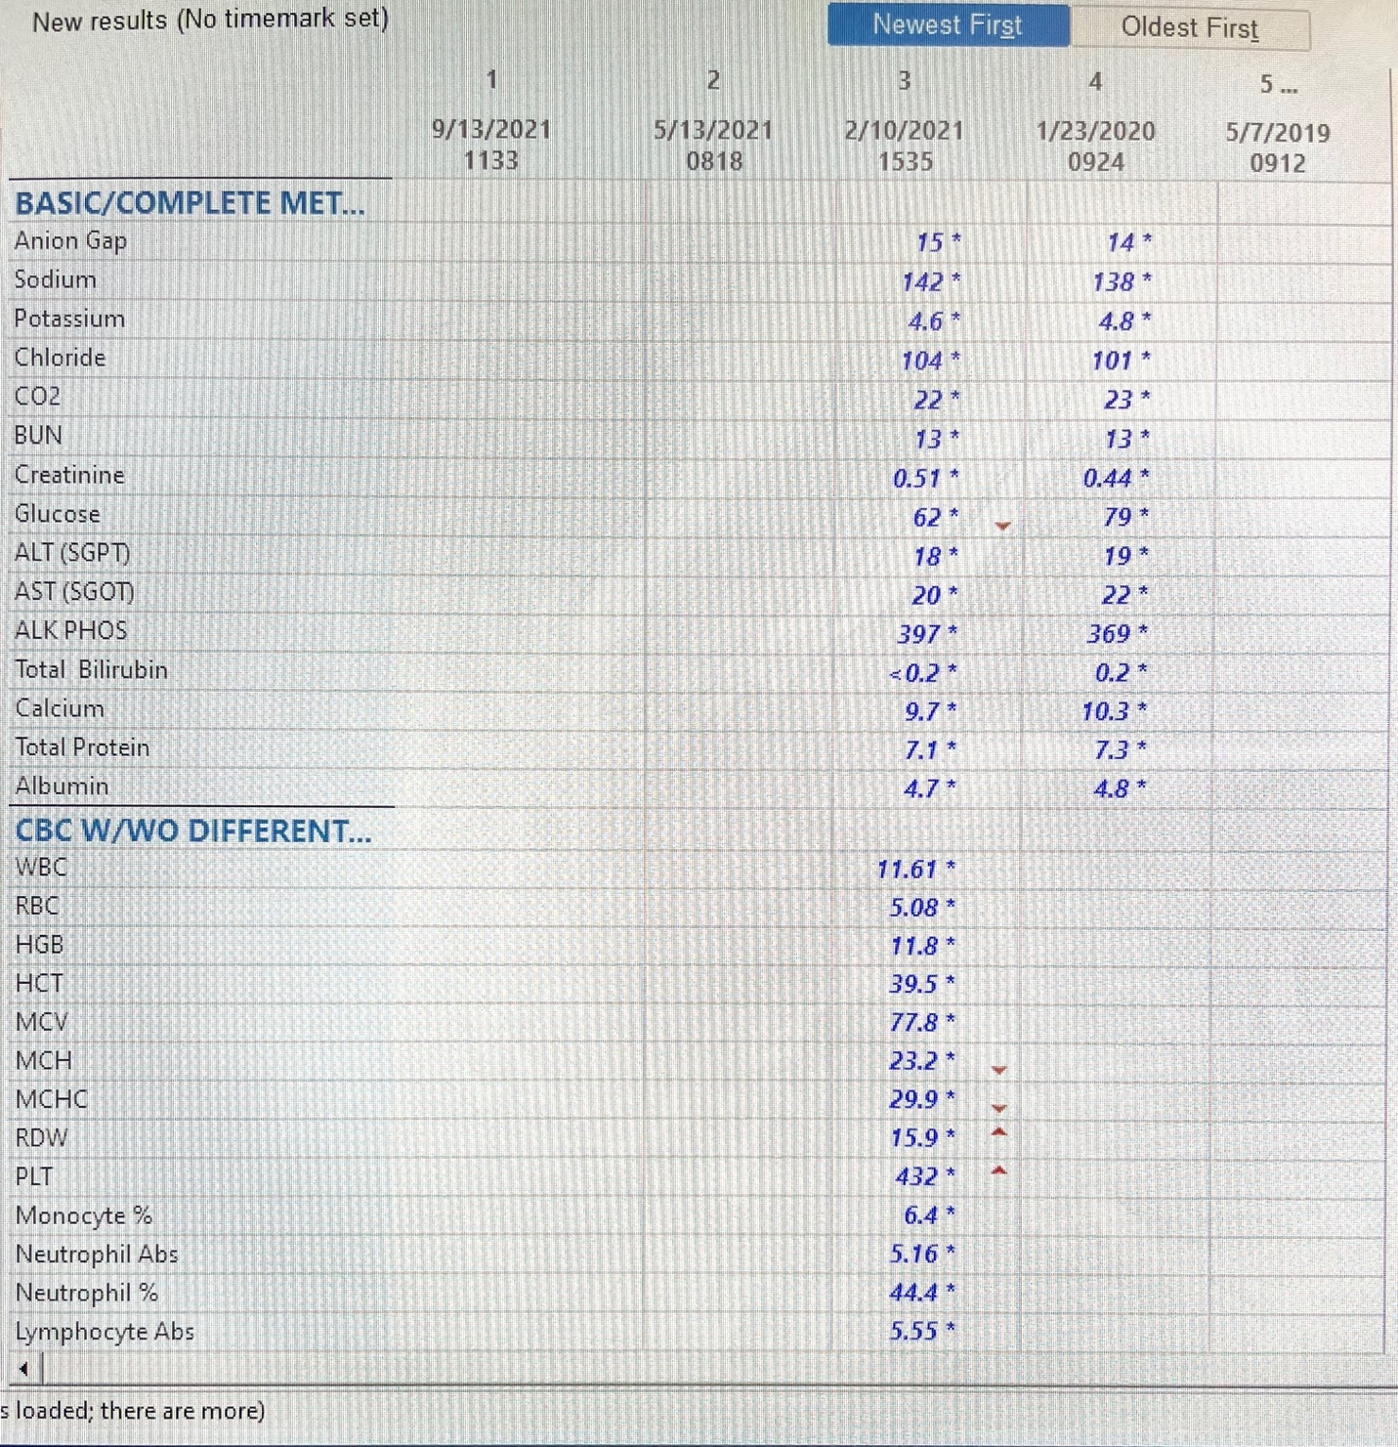

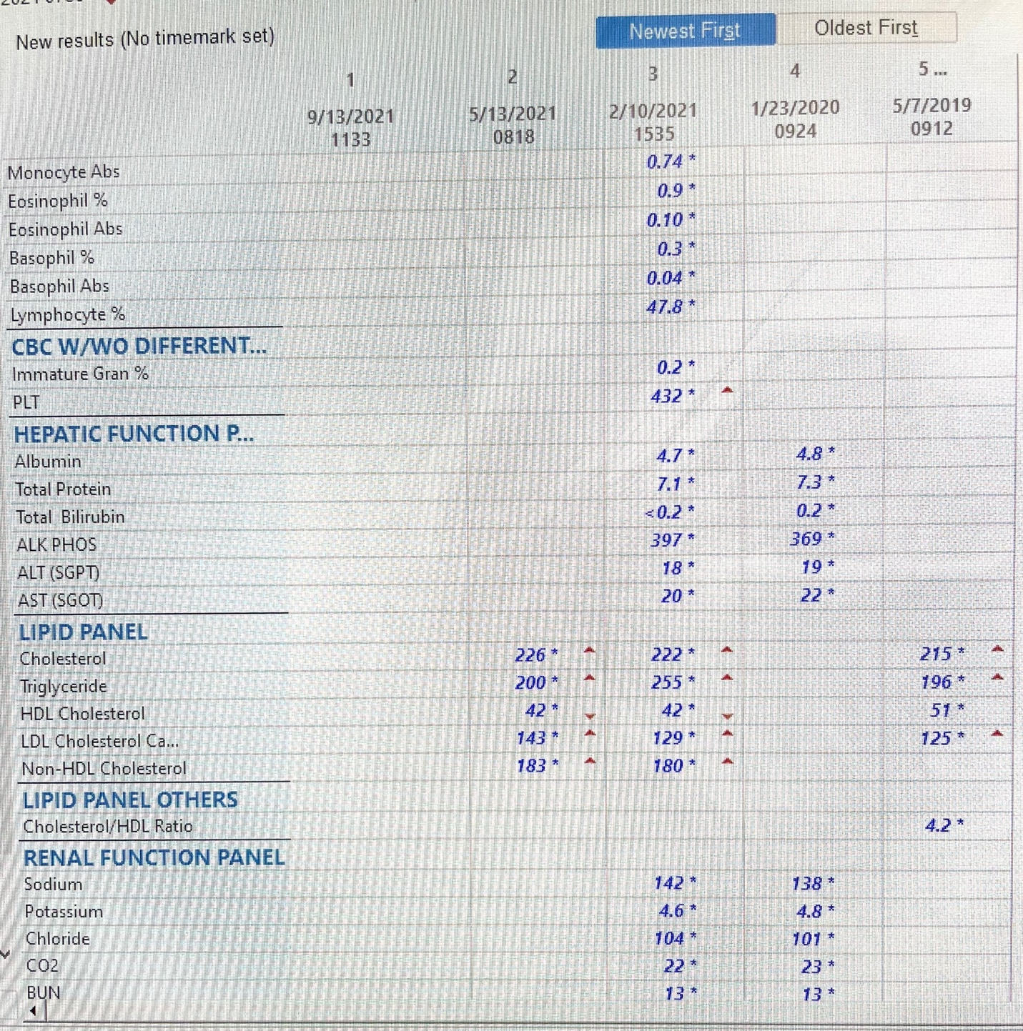

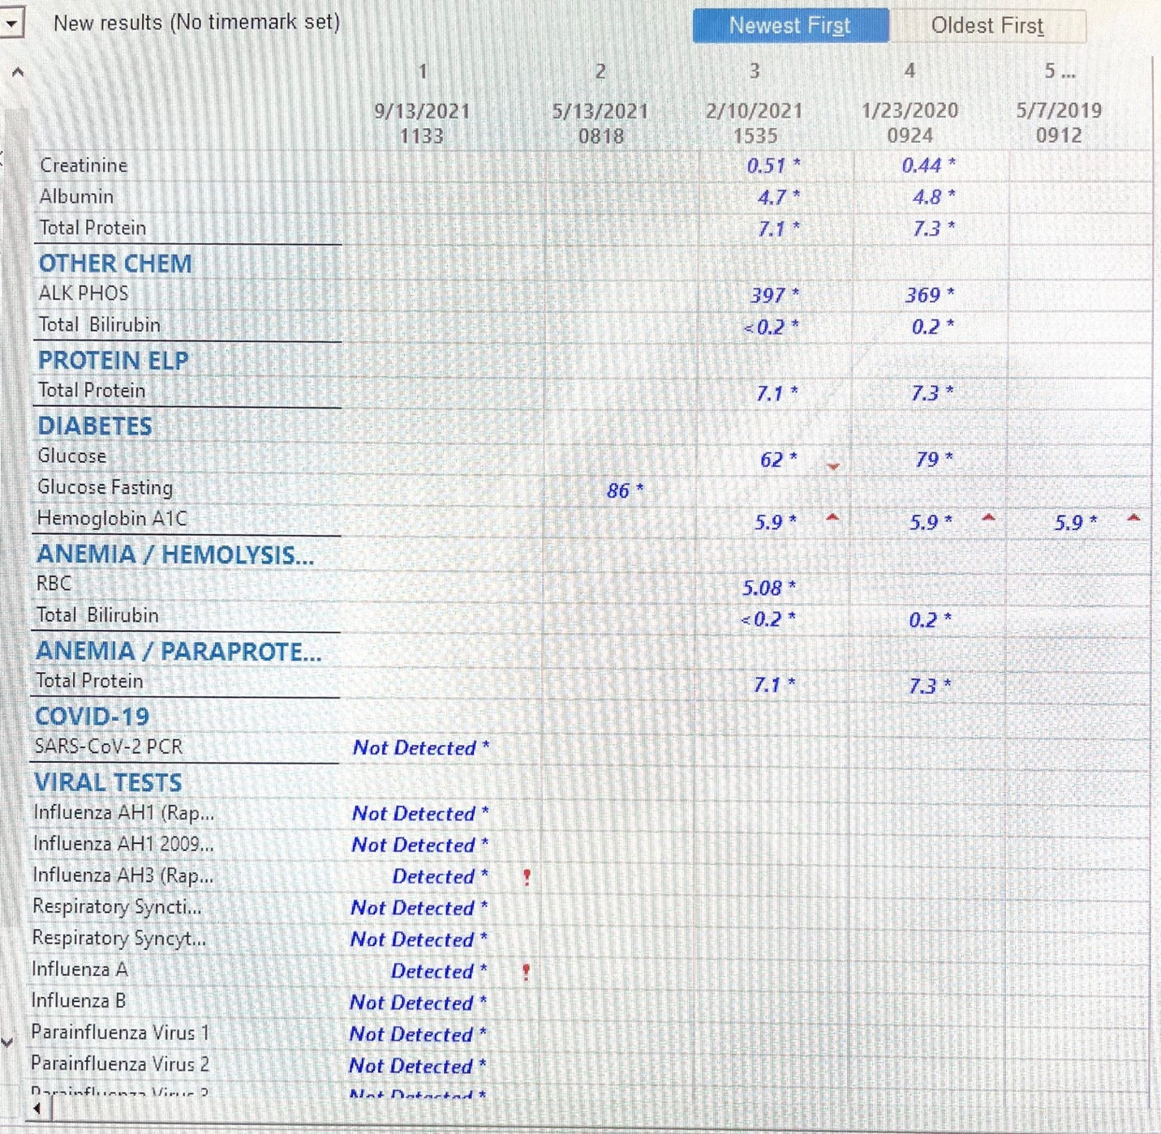

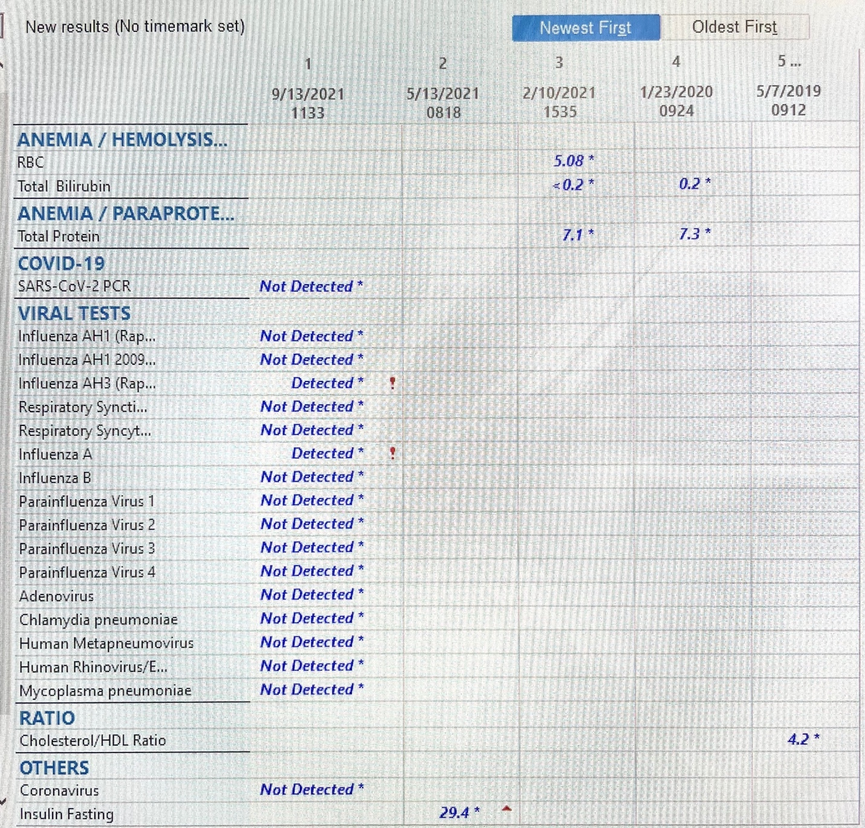

Progress Note
Patient improved air entry in lungs s/p Albuterol administration. Saturating 99% on RA. Tolerating liquids and food well. Genmark results reviewed with mom, Influenza A positive. Discussed benefits and side effects of treatment with Tamiflu. Patient is still within 48 hour window of symptom onset, and mom would like the prescription of Tamiflu. Script sent for 150mg divided into 2 doses for 5 days to QHC pharmacy. Albuterol HFA with spacer use demonstrated and script for Albuterol sent to QHC pharmacy. Reviewed signs of respiratory distress, anticipatory guidance provided (use of humidified air, rest, hydration). Importance of vaccination discussed. Mom verbalized understanding. Follow up with PCP in 2-3 days, return to ED if any concerns.

